

P.S.S.A. TESTING WINDOW FOR 2024 – 2025

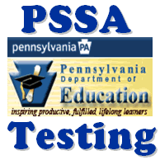

Assessment | Dates | Grades
English Language Arts (E.L.A.) | April 21, April 22, April 23, April 24 and April 25, 2025 | Grades 3 - 8
Mathematics | April 28, April 29, 2025 | Grades 3 - 8
Science | April 30, May 1, 2025 | Grades 4 and 8

